A Process Module for a Multi-User Service Program
Plastic MEMS (PMEMS)
Design
Handbook

A Michigan Nanofabrication Facility process at the University of Michigan

August 2005
Modified September 2006
TABLE OF CONTENTS

Chapter 1 3
Plastic Microelectromechanical Systems (MEMS) Process 3
1.1 Introduction 3
1.2 Process Flow 4
Chapter 2 11
An Overview of the Layout Design Rules 11
2.1 Introduction 11
2.2 Electrode Mask 13
2.3 Sacrificial Photoresist Mask 13
2.4 Release Mask 14
2.5 Access Mask 15
2.6 SU-8 Mask 15
2.7 Die Size 15
2.8 Design Submission 15
Chapter 3 Materials properties 16

Chapter 1

Plastic Microelectromechanical Systems (MEMS) Process

Introduction
Plastic microelectromechanical systems (PMEMS) process has been developed for microfluidics and bioMEMS applications. The fabrication process mainly uses parylene to form channels and SU-8 to planarize the surface for external tube coupling. This process is a low temperature process (maximum temperature of 90 °C) and can use any substrate including plastic, glass and silicon. Therefore, it is CMOS compatible and can be used to integrate microfluidics with CMOS. Furthermore, by using plastic substrates, cheap and disposable microfluidic devices can be fabricated.

Parylene microchannel fabrication technology utilizing structures produced by releasing sacrificial photoresist, has been developed by Prof. Carlos H. Mastrangelo and Drs. Francis P. Man and James R. Webster at the University of Michigan, and has been geared towards integrated microfluidic systems. The first demonstrated example was an integrated DNA electrophoresis chip with an integrated light emitting diode detection system. The advantages of using this process are: the parylene film is conformal, pin-hole free, deposited at room temperature; has lower out-gassing and lower permeability to liquids and gasses as compared to other polymers; has high optical clarity and no background fluorescence; is a good electrical insulator; is chemically inert; and is biocompatible. The most important property for this application is that parylene can be easily integrated with CMOS. Furthermore, it can be used to integrate multiple levels of micro-channels, electrodes and micro-heaters.

Parylene can also be used as a mechanical material to fabricate surface micromachined beams, diaphragms and cantilevers for applications that require low Young’s modulus. Therefore, parylene technology can be used as a platform to integrate CMOS and electrodes, heaters, microchannels, cantilevers, beams and diaphragms. However, the biggest disadvantage and challenge in parylene microfabrication is its low adhesion. Even though, parylene has lower permeability to gases and liquids compared to other polymers, it is still permeable to them. Therefore, if the parylene is left in strong acids, bases or solvents, they permeate through the film and attack the adhesion layer, peeling the film from the surface. Also, temperatures higher than 90 °C, will cause thermal stresses in the film as a consequence of its high thermal expansion of coefficient and can cause delamination of the parylene film from the substrate.

Even though, this process is capable of having multiple levels of metals for electrodes and heaters and multiple levels of parylene depositions for fluidic channels and mechanical devices, in this process only one level of metal patterning and one layer of sacrificial layer patterning are included. However, in the future, depending on the user demand and requests, steps can be added to have multiple layers of metal and parylene.

This document gives details about the process flow and design rules of the plastic MEMS process. The process flow developed for the fabrication of fluidic devices can be outlined with the following individual steps.
- Coating substrate with parylene as a base material.
- Forming electrodes
- Patterning thick sacrificial photoresist to form microchannels.
- Depositing parylene to form channel walls.
- Etching release holes on parylene to release sacrificial photoresist.
- Releasing sacrificial photoresist in acetone.
- Sealing the release holes with another parylene deposition.
- Patterning a metal mask for the access holes for electrode pads and reservoirs.
- Patterning SU-8 to planarize reservoir area for external fluidic coupling.
- Etching parylene to form the access holes with the protection of the metal mask patterned previously.
- Removing the metal mask.

In this chapter, an overview of the process flow is given with both top and cross-sectional views of the substrates. In the next chapter, layout design rules are explained with top view demonstrations relating the process to the mask design drawn using any commercial layout editor, such as Mentorgraphics’ IC station and Tanner’s Ledit.

Process Flow
The process starts by coating substrate with 6 μm thick layer of parylene as shown in Fig. 1.1. In this figure, the top picture shows the top view of the substrate and the bottom picture shows the cross-sectional view cut along the A-A’ line. As a default glass is used as a substrate, and will be used in the beta test run. However, this can be any type of substrate such as silicon, plastic, metal…etc.
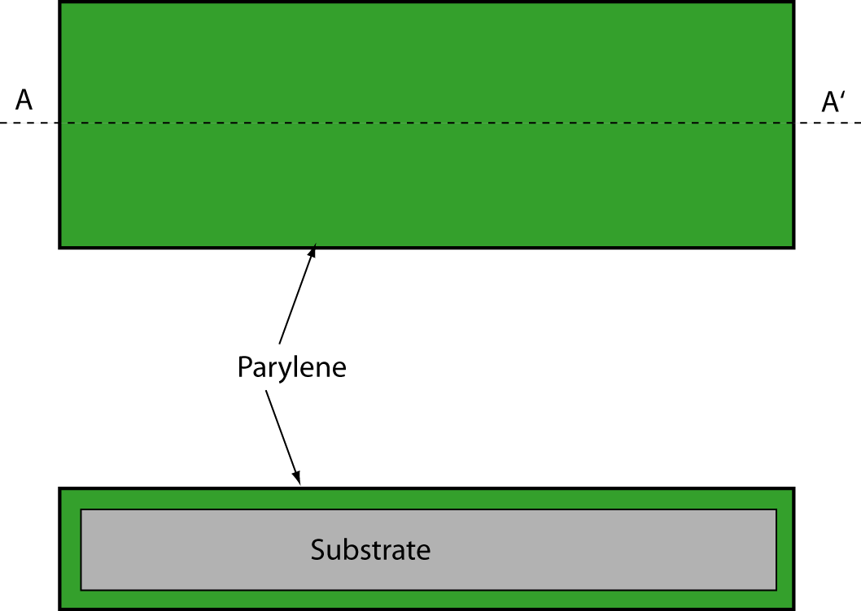
Fig. 1.1. Substrate is coated with 6 μm thick parylene. Any substrate can be used for this process. Default substrate used here will be glass. Top picture shows the top view and the bottom shows the cross-sectional view along A-A’ line.

As a next step, 0.03/0.5 μm thick Cr/Au layer is evaporated and patterned using the mask ELECTRODE as shown in Fig. 1.2. This metal layer typically serves as electrodes and microheaters.

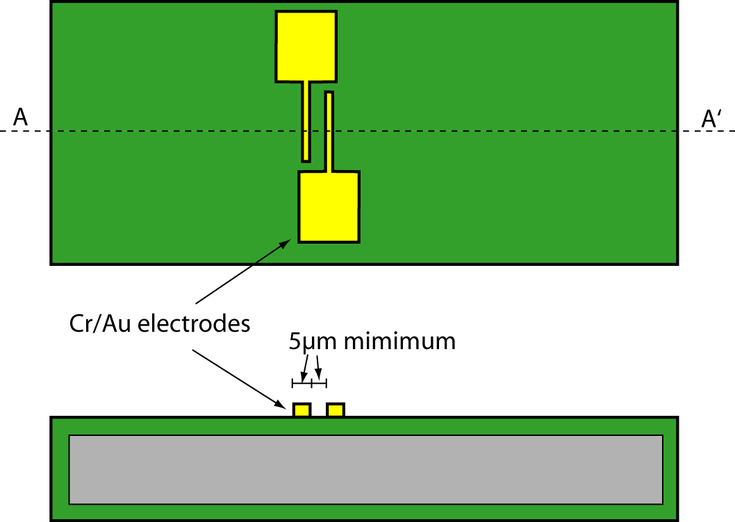
Fig. 1.2. 30/500 nm Cr/Au layer is evaporated and patterned to form electrodes, heaters or for other purposes.
After the metal layer, 10 μm thick sacrificial photoresist is patterned to form microfluidic channels as shown in Fig. 1.3. In this figure a simple microchannel structure is depicted with two reservoirs. Since this sacrificial layer will be coated with parylene and then it will be released in acetone through openings formed in parylene, if the channel is longer than 1.5 mm, release holes must be opened every 1.5 mm. Instead of opening these holes in the main channel area, special areas on the sides of the channels can be created as shown in this figure labeled release hole area.

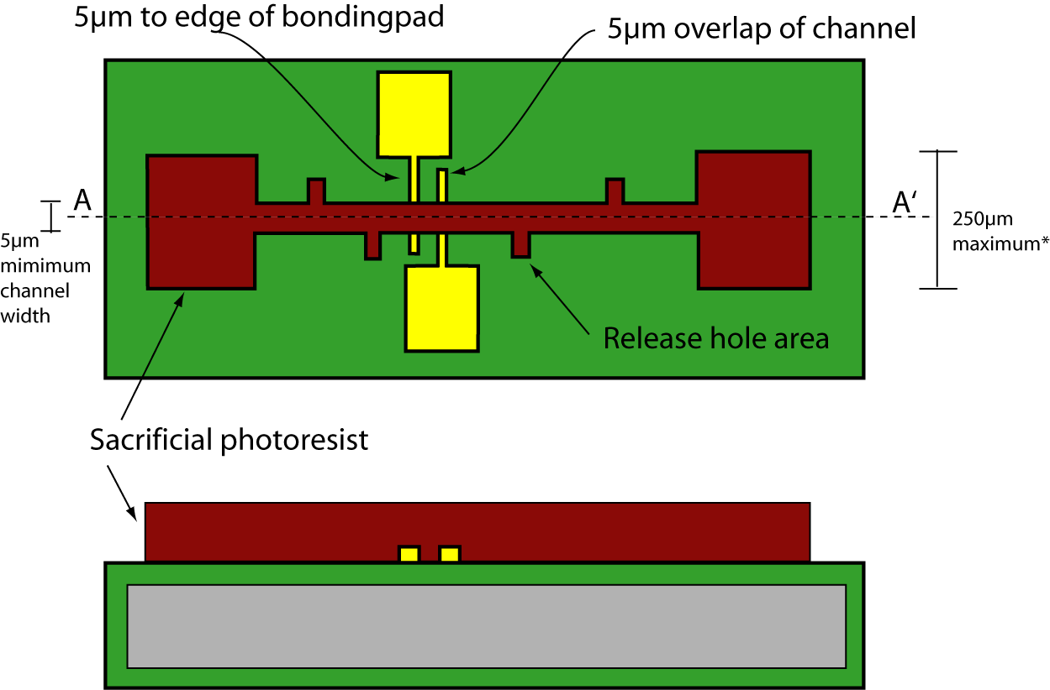
Fig. 1.3. 10 μm thick photoresist is patterned as sacrificial layer to form microfluidic channels and chambers. Uses the mask THICK_PR. The release hole area prevents the later sealing of the channel. *Chambers larger than 200µm can be produced if posts are used (see section 2.3 Sacrificial Photoresist Mask).

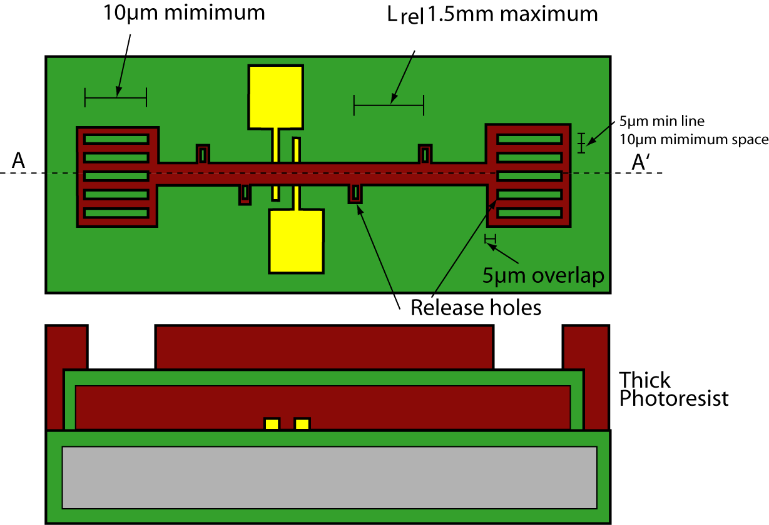
Fig. 1.4. 3 μm thick parylene is deposited onto the substrate. This uses the mask RELEASE

After patterning the sacrificial layer, 3 μm thick parylene is deposited. This parylene coating is a chemical vapor deposition (CVD) and the substrate remains at room temperature. The CVD parylene coating is very conformal. Following deposition, a 10 μm thick photoresist is patterned on parylene, which will be used to make openings in the top parylene film. The openings will be used to release the sacrificial photoresist inside the parylene channels with acetone and the completed device is shown in Fig. 1.5. These release holes have to be 5 μm wide and separated by at least a 10 μm gap. The release holes must be repeated at least every 1.5 mm along the channel.

IMPORTANT: for improved releasing from the sacrificial photoresist, the holes are positioned over of the patterned sacrificial photoresist in special areas beside the channel. Do not place the release holes over the channel because it can cause the channels to seal themselves, and will reduce the height of the channel in those areas.

Next, the masking layer is patterned, parylene is dry etched using oxygen plasma. Then, the wafer is soaked in acetone for 8 hours, followed by two acetone and IPA rinses to release the sacrificial photoresist inside the parylene channels as shown in Fig. 1.5.

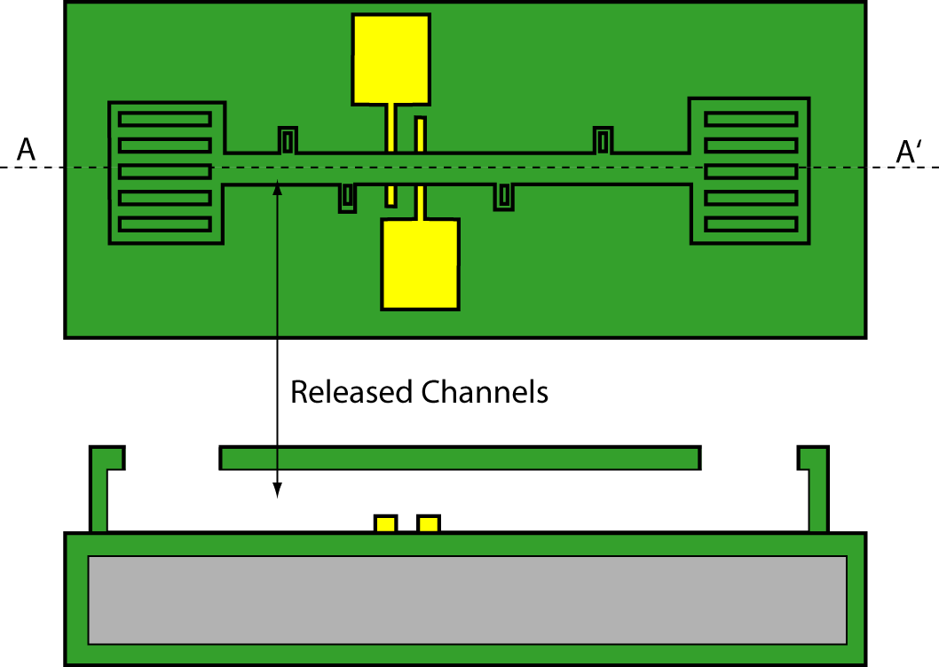
Fig. 1.5. The sacrificial photoresist is soaked into acetone for 8 hours and released. Acetone and IPA rinse are done multiple times.

In some micro-fluidic applications, it may be desirable to pressurize the liquid inside the channels with an external pressure source. However, this will not be possible for long channels where the release holes remain opened, which are required to properly release channels as discussed. Therefore, in order to be able to pressurize the liquids inside these channels requires that the release holes be sealed. As a design rule, release holes have been set to be a maximum of 5 μm wide slits with 10 μm gap (parylene remains) between them. With this design rule, it is possible to seal these openings with 3 μm thick parylene deposition. However, in this process 9 μm parylene deposition has been used to guarantee the sealing of the release holes.
Therefore as a next step, 6 μm parylene is deposited as shown in Fig. 1.6. Again, this deposition utilizes CVD and it is very conformal. Therefore, parylene penetrates long distances down the channels and the coats inside before it seals the release holes. As a result, the channel walls become thicker from the inside, therefore reducing the channel widths by a few microns.
After sealing the channels, openings must be made in the fluidic reservoir and to the electrode pad areas by etching away parylene in these areas. Step coverage issues for this mask require patterning before spinning 75 μm thick SU-8 to planarize reservoir areas. However, parylene is not etched until after the SU-8 patterns are formed. As a result, after release holes are sealed, 0.5 μm thick Ti layer is evaporated onto the substrate and patterned with the mask ACCESS as shown in Fig. 1.7. The titanium mask should cover most of the wafer except for the reservoir and electrode pad openings where parylene is to be etched. Furthermore, Ti layer will be removed wherever there will be SU-8 patterns. This is a reversed mask and therefore all areas that are not patterned will be covered by titanium.

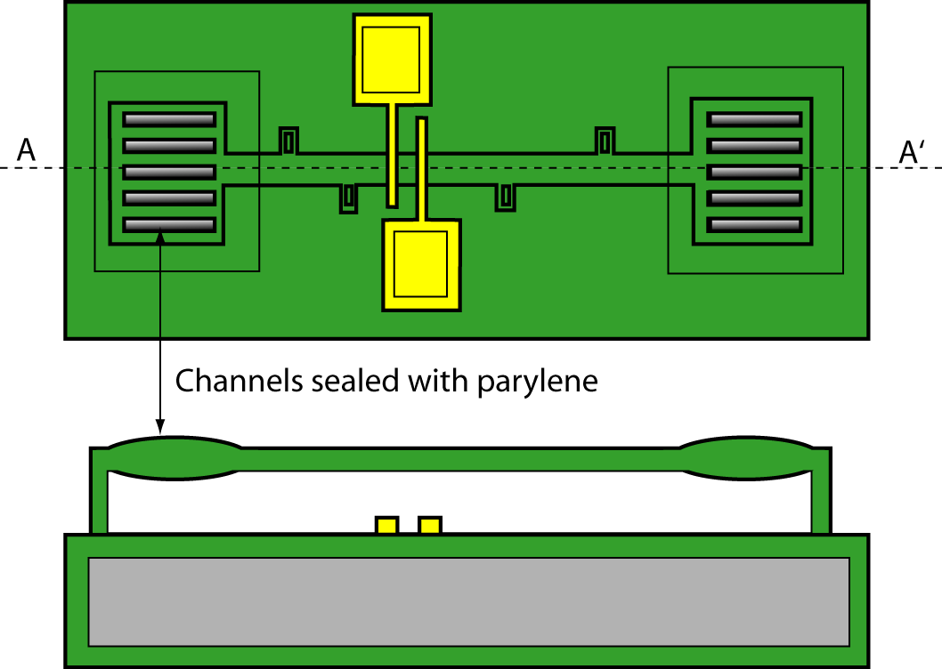
Fig. 1.6. 6 μm thick parylene is deposited to seal the slits used to release channels.

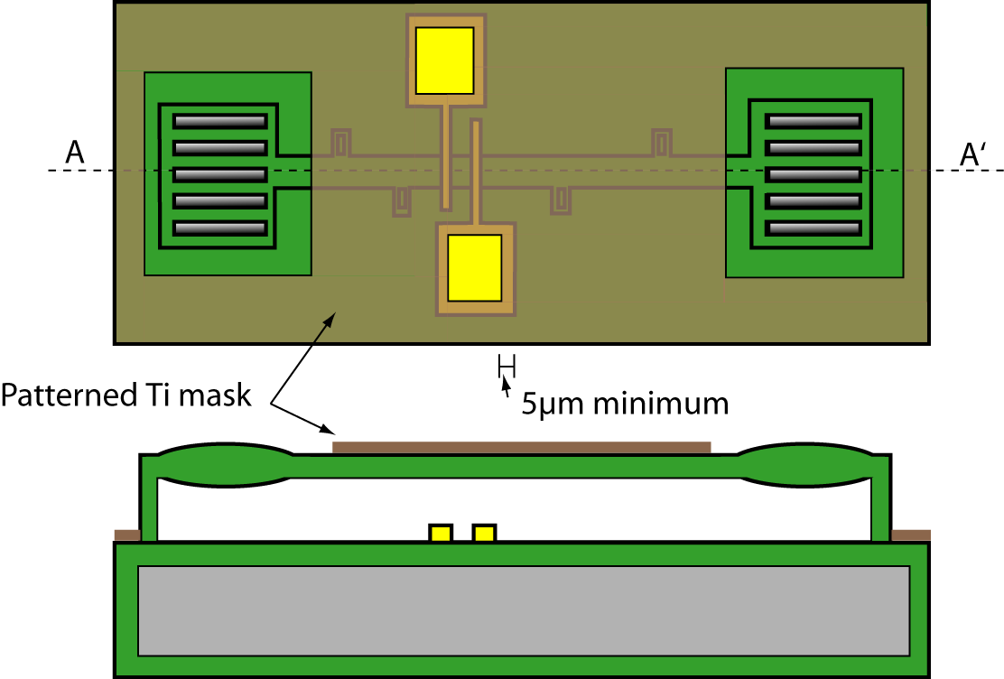
Fig. 1.8. Titanium mask is used for patterning of the micro-fluidic access and electrode contacts using the mask ACCESS. The drawn pattern for this mask layer is where there is no titanium remaining.

After Ti mask layer is patterned, parylene is not etched immediately. Instead, 75 μm thick SU-8 is spun on the substrate. Then, SU-8 layer is patterned using the mask SU-8 as shown in Fig. 1.9. Once the SU-8 patterns are developed, they will stay there permanently. They can not be dissolved in most solvents. Developed SU-8 patterns are inert to chemicals. In this process, this thick SU-8 layer is used to planarize the reservoir areas so that external fluidic connections can be made to the appropriate areas. Therefore, SU-8 layer should cover a large area around the reservoir area except for the reservoir opening area, where an opening has already been patterned using the Ti mask. As a recommendation, the outer diameter of the SU-8 pattern, should be at least as large as the outer diameter of the tubing, that will be used to connect to the micro-fluidic system. This will provide a level area to bond the tubing to the micro-fluidic chip.

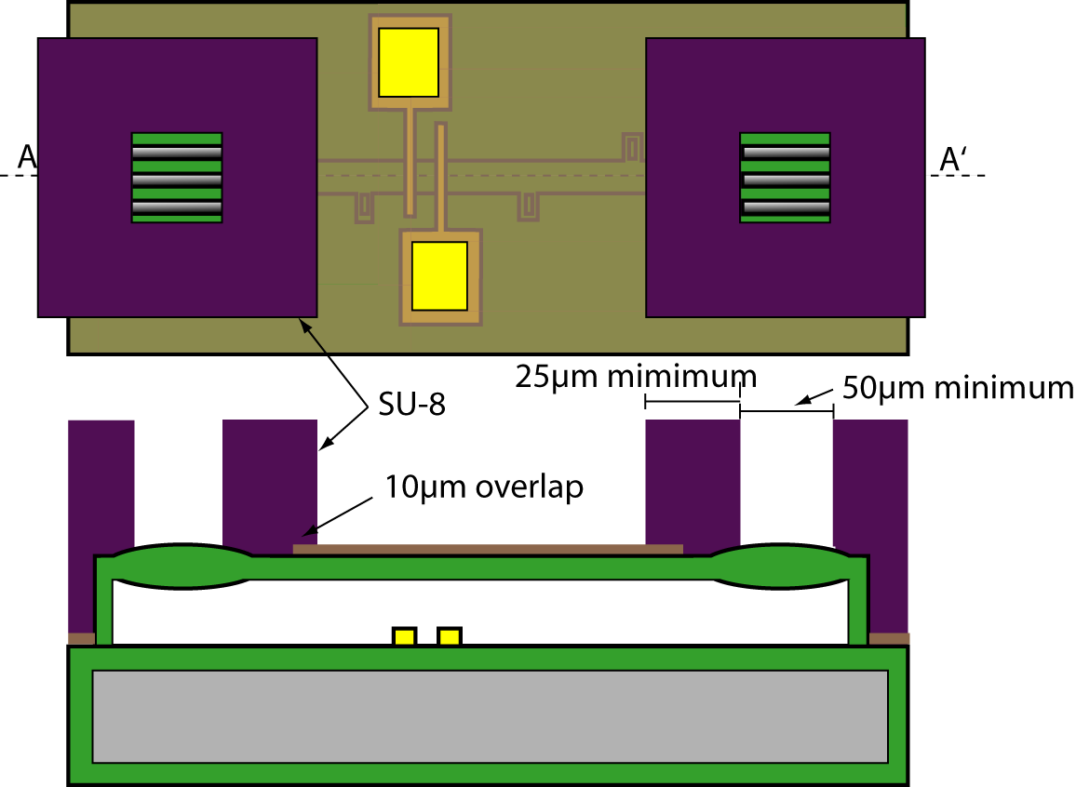
Fig. 1.9. 75 μm thick SU-8 is spun and patterned using the mask SU-8. This step will planarize the reservoir area so that external fluidic connectors can seat correctly and establish fluidic connection. Therefore, it is advised to have SU-8 pattern only around reservoirs.

After SU-8 is patterned, the substrate is put into a reactive ion etcher with oxygen plasma to etch through the parylene layers exposed through SU-8 and Ti layers. At this step, reservoir and electrode pad openings are formed. This oxygen plasma etch also etches a few microns of the 75 µm thick SU-8 and roughens its surface.
Titanium layer patterned in the previous steps act as the masking layer for this etch.
As a result of exposure to the oxygen plasma, the SU-8 loses its optical clarity after this step. Therefore, if optical clarity is important on a microchannel, SU-8 patterns should not be left on these areas. As a final step, Ti layer is wet etched yielding a structure shown in Fig. 1.9.
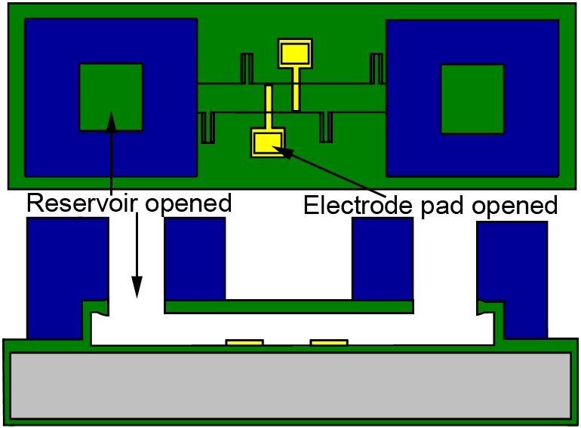
Fig. 1.9. Parylene is etched in oxygen plasma to open reservoir areas and electrode pad openings.

After the final step, an external fluidic connection can be pressed upon the SU-8 areas used to planarize the reservoir areas as shown in Fig. 1.10. By pressing down the external fluidic connectors, a tight seal can be established between the external connector and the micro-channels. The force applied to SU-8 patterns would not collapse the micro-channels because SU-8 patterns conformally cover a large area which is mostly sitting on the substrate (no channel). Therefore, SU-8 patterns would not bend and collapse the parylene channels. This is the reasoning behind planarizing reservoir areas with SU-8.

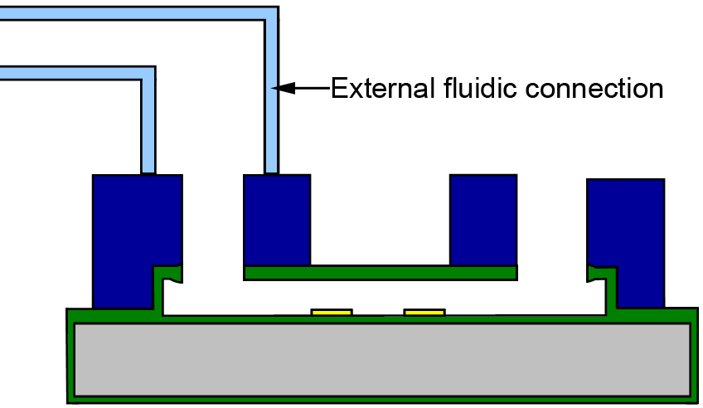
Fig. 1.10. An external tube can have a good fluidic connection to the microfluidic channel with planar SU-8 patterns around the reservoir by pressing down the tube to these patterns.

Chapter 2

An Overview of the Layout Design Rules

2.1 Introduction
In this chapter, layout design rules are explained further with the aid of some examples. These design rules have been developed from previous fabrication experience and show process limitations and design considerations. With the help of top view examples, the process flow, and cross-sectional drawings shown in the first chapter, layout rules should be clear.

Minimum feature sizes reported here are mostly limited by the resolution and alignment capability of the lithography steps and the uniformity and the resolution of the etching tools. These minimum feature sizes should not be used unless it is absolutely necessary. If it is not critical, features should be drawn larger than the minimum size reported here.

Related lithography layer names, for which material they are used and for what purpose are summarized in Table 2.1. In this table, drawing convention is also given.

Lithography Level Name | GDS Level number | Material | Drawn area stays or removed? | Purpose/Comments
ELECTRODE | 1 | Cr/Au | Stays | To form electrodes electrically connected to the fluid in the conduit
THICK_PR | 2 | 10 μm thick photoresist | Stays | The drawn area forms the micro-fluidic channels
RELEASE | 3 | Parylene | Removed | To open release holes through the top layer of parylene. A thicker region will result in this area when the holes are resealed.
ACCESS | 4 | Ti, eventually parylene | Removed | To open access holes for fluidic connection to the reservoirs and open contacts to the electrode pads.
SU-8 | 5 | SU-8 | Stays | To planarize reservoir areas for external fluidic coupling. SU-8 is a negative photoresist.
Table 2.1. Lithography layers, materials and drawing conventions.

Table 2.2 summarizes the minimum feature sizes and registration layers in each layout layer. Table 2.3 summarizes two process limitations, namely collapsing of channels wider than 250 μm if the bottom layer is parylene and SU-8’s losing optical clarity after oxygen plasma etch. The following sections explain these mask layers.

Lithography Level Name | Material | Min. feature (μm) | Min. space (μm) | Max. feature (µm) | Layer Registration /  Comments
ELECTRODE | Cr/Au | 5 | 5 | - | · Extend line past edge of THICK_PR by 5µm to assure complete channel coverage.  · Distance From THICK PR to edge of bonding pad 10µm.  · Larger than ACCESS for bonding pad by 10µm.  · See Figure 1.2 and 1.3
THICK_PR | Photoresist | 10 | 10 | 200* | * See section 2.3 for producing wider channels.  · Distance from edge of channel to overlap of ELECTRODE is 5µm.  · For resevoir fluidic contacts THICK_PR wider than ACCESS by 10 µm.  · Do not place release holes over open channel  · See Fig. 1.3 and Fig. 2.1
RELEASE | Parylene | 5 | 10 | * | · Distance to edge of THICK_PR 10µm.  · Length to next group of RELEASE holes along channel 1.5mm  · Minimum length of release hole 10µm.  * Maximum width of release hole 5µm.  - Recommended at least 4 release holes near a long or large area of THICK_PR.  - Strongly recommended: do not place release holes over the micro-fluidic flow channel. Place holes to the side of the channel in special areas.  · See Figure 1.4 2.2
ACCESS | Ti | 5 | 10 | - | · Inverted mask (drawn holes will etch through to micro-fluidic channels and gold)  · Distance to edge of ELECTRODE bonding pad 5µm.  · Minimum distance to edge of SU-8 10µm  · See Figure 1.8
SU-8 | SU-8 | 25 | 50 | - | · Drawn will remain as a 50 µm thick layer of SU-8  · Distance to edge of ELECTRODE bonding pad 20µm.  · Recommendation: For optical devices do not have SU-8 over channel.  · See Figure 2.4
Table 2.2. Minimum features and registration of layers.

Process Limitation | Comments
Releasing parylene structures | If parylene conduit is over parylene (rather than gold) and if one dimension is larger than 200 μm, the structure will collapse. However, if the parylene is over gold, the released structure will not collapse up to a distance of least 800 µm.
After oxygen plasma, SU-8 patterns lose optical clarity | If optical clarity is desired on channels, there should not be any SU-8 pattern where the optical clarity is required.  SU-8 can be used over the channels to improve
Table 2.3. Critical process limitations that have to be taken into account during the layout.

2.2 Electrode Mask
ELECTRODE mask is intended for the formation of electrodes or microheaters that may be desired in microfluidic or bioMEMS applications. As shown in table 2.1, any box drawn in this mask, stays as a Cr/Au pattern on the real wafer. Minimum feature size can be 4 μm with a gap of 4 μm as summarized in table 2.2.

2.3 Sacrificial Photoresist Mask
The mask layer that patterns the sacrificial photoresist is called THICK_PR. As shown in table 2.2, the minimum feature size on this layer is 10 μm. The minimum gap between patterns is also 10 μm. However, the patterns on these structures can not be infinitely large. The limitation is caused by the permanent stiction of released structures to the surface because of the high surface tension created as the liquid under the structure dries after releasing them in acetone and IPA. Because of this limitation, cantilevers, beams, diaphragms and channels that have dimensions greater than specific values will not be released and stick to the surface if they do not have any posts.

As mentioned in table 2.3, if the parylene structure is over a parylene surface, then structures that have two dimensions (length and width) greater than 200 μm will collapse. This means that as long as one dimension is less than 200 μm, that structure will not collapse. If channels that have both dimensions larger than 200 μm are desired, then posts are required. These posts can be created by making openings in the THICK_PR mask layer every 200 μm as shown in Fig. 2.1. However, if large structures are formed over a gold surface (using the ELECTRODE layer), then the releasing does not result in a collapse of the structure or channel if the geometry is less than 750 µm. Do not place the gold (ELECTRODE) layer withing 5 µm of the support posts. Therefore, gold can be kept underneath the sacrificial photoresist patterns to enable better release of the structures and the larger structure will remain open. However, the gold layer can not be removed later in the process.
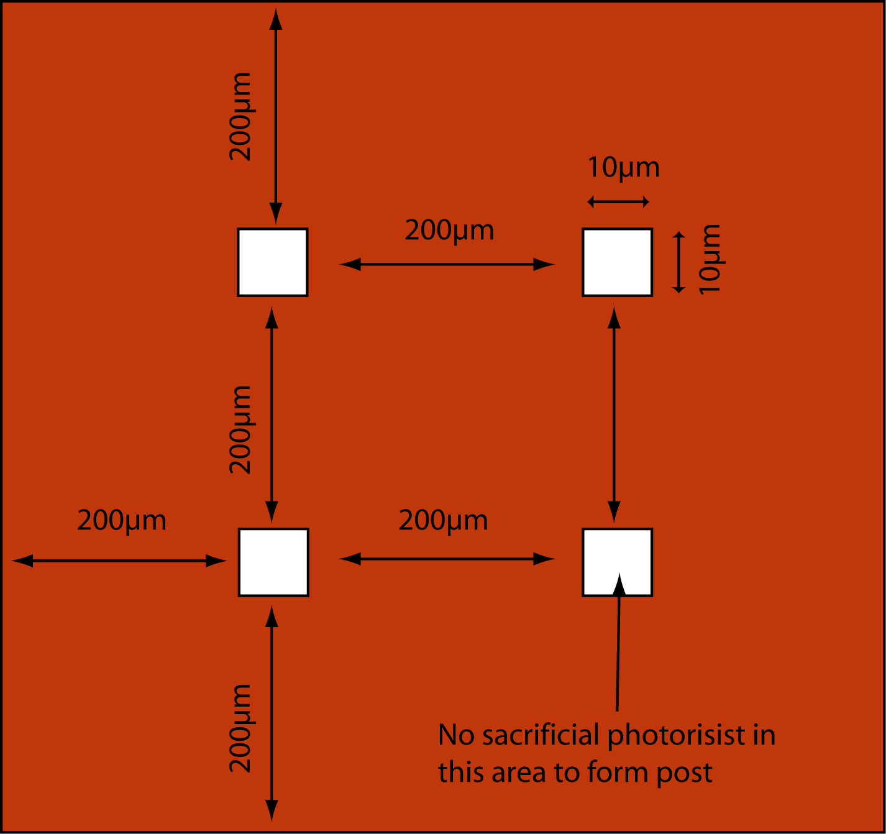

Fig. 2.1. If parylene structures are over parylene and very large structures are going to be released, posts have to be created every 200 μm. This can be achieved by creating a post that is at least a 5x5 μm² opening on the THICK_PR mask every 200 μm.

2.4 Release Mask
The RELEASE mask is used to open release holes in the parylene channels to release the sacrificial photoresist. As summarized in table 2.2, the maximum hole width is 5 μm and the minimum gap between openings is 10 μm. If the micro-channels are going to be longer than 1.5 mm, additional release holes are needed along the length of the channel. The release holes should be placed at the edge of the channel rather than over the channel because the release hole area will be thinner than the rest of the channel. These holes can be in the form of parallel slits as shown in Fig. 2.2. A minimum of four slits in parallel is recommended for optimal release of the conduits or chambers. For the channels, it is suggested to have special release areas on the side of the channels as shown in Figs 1.3 and 1.4. Typically these parallel slits can be 100 μm long and 5 µm wide.
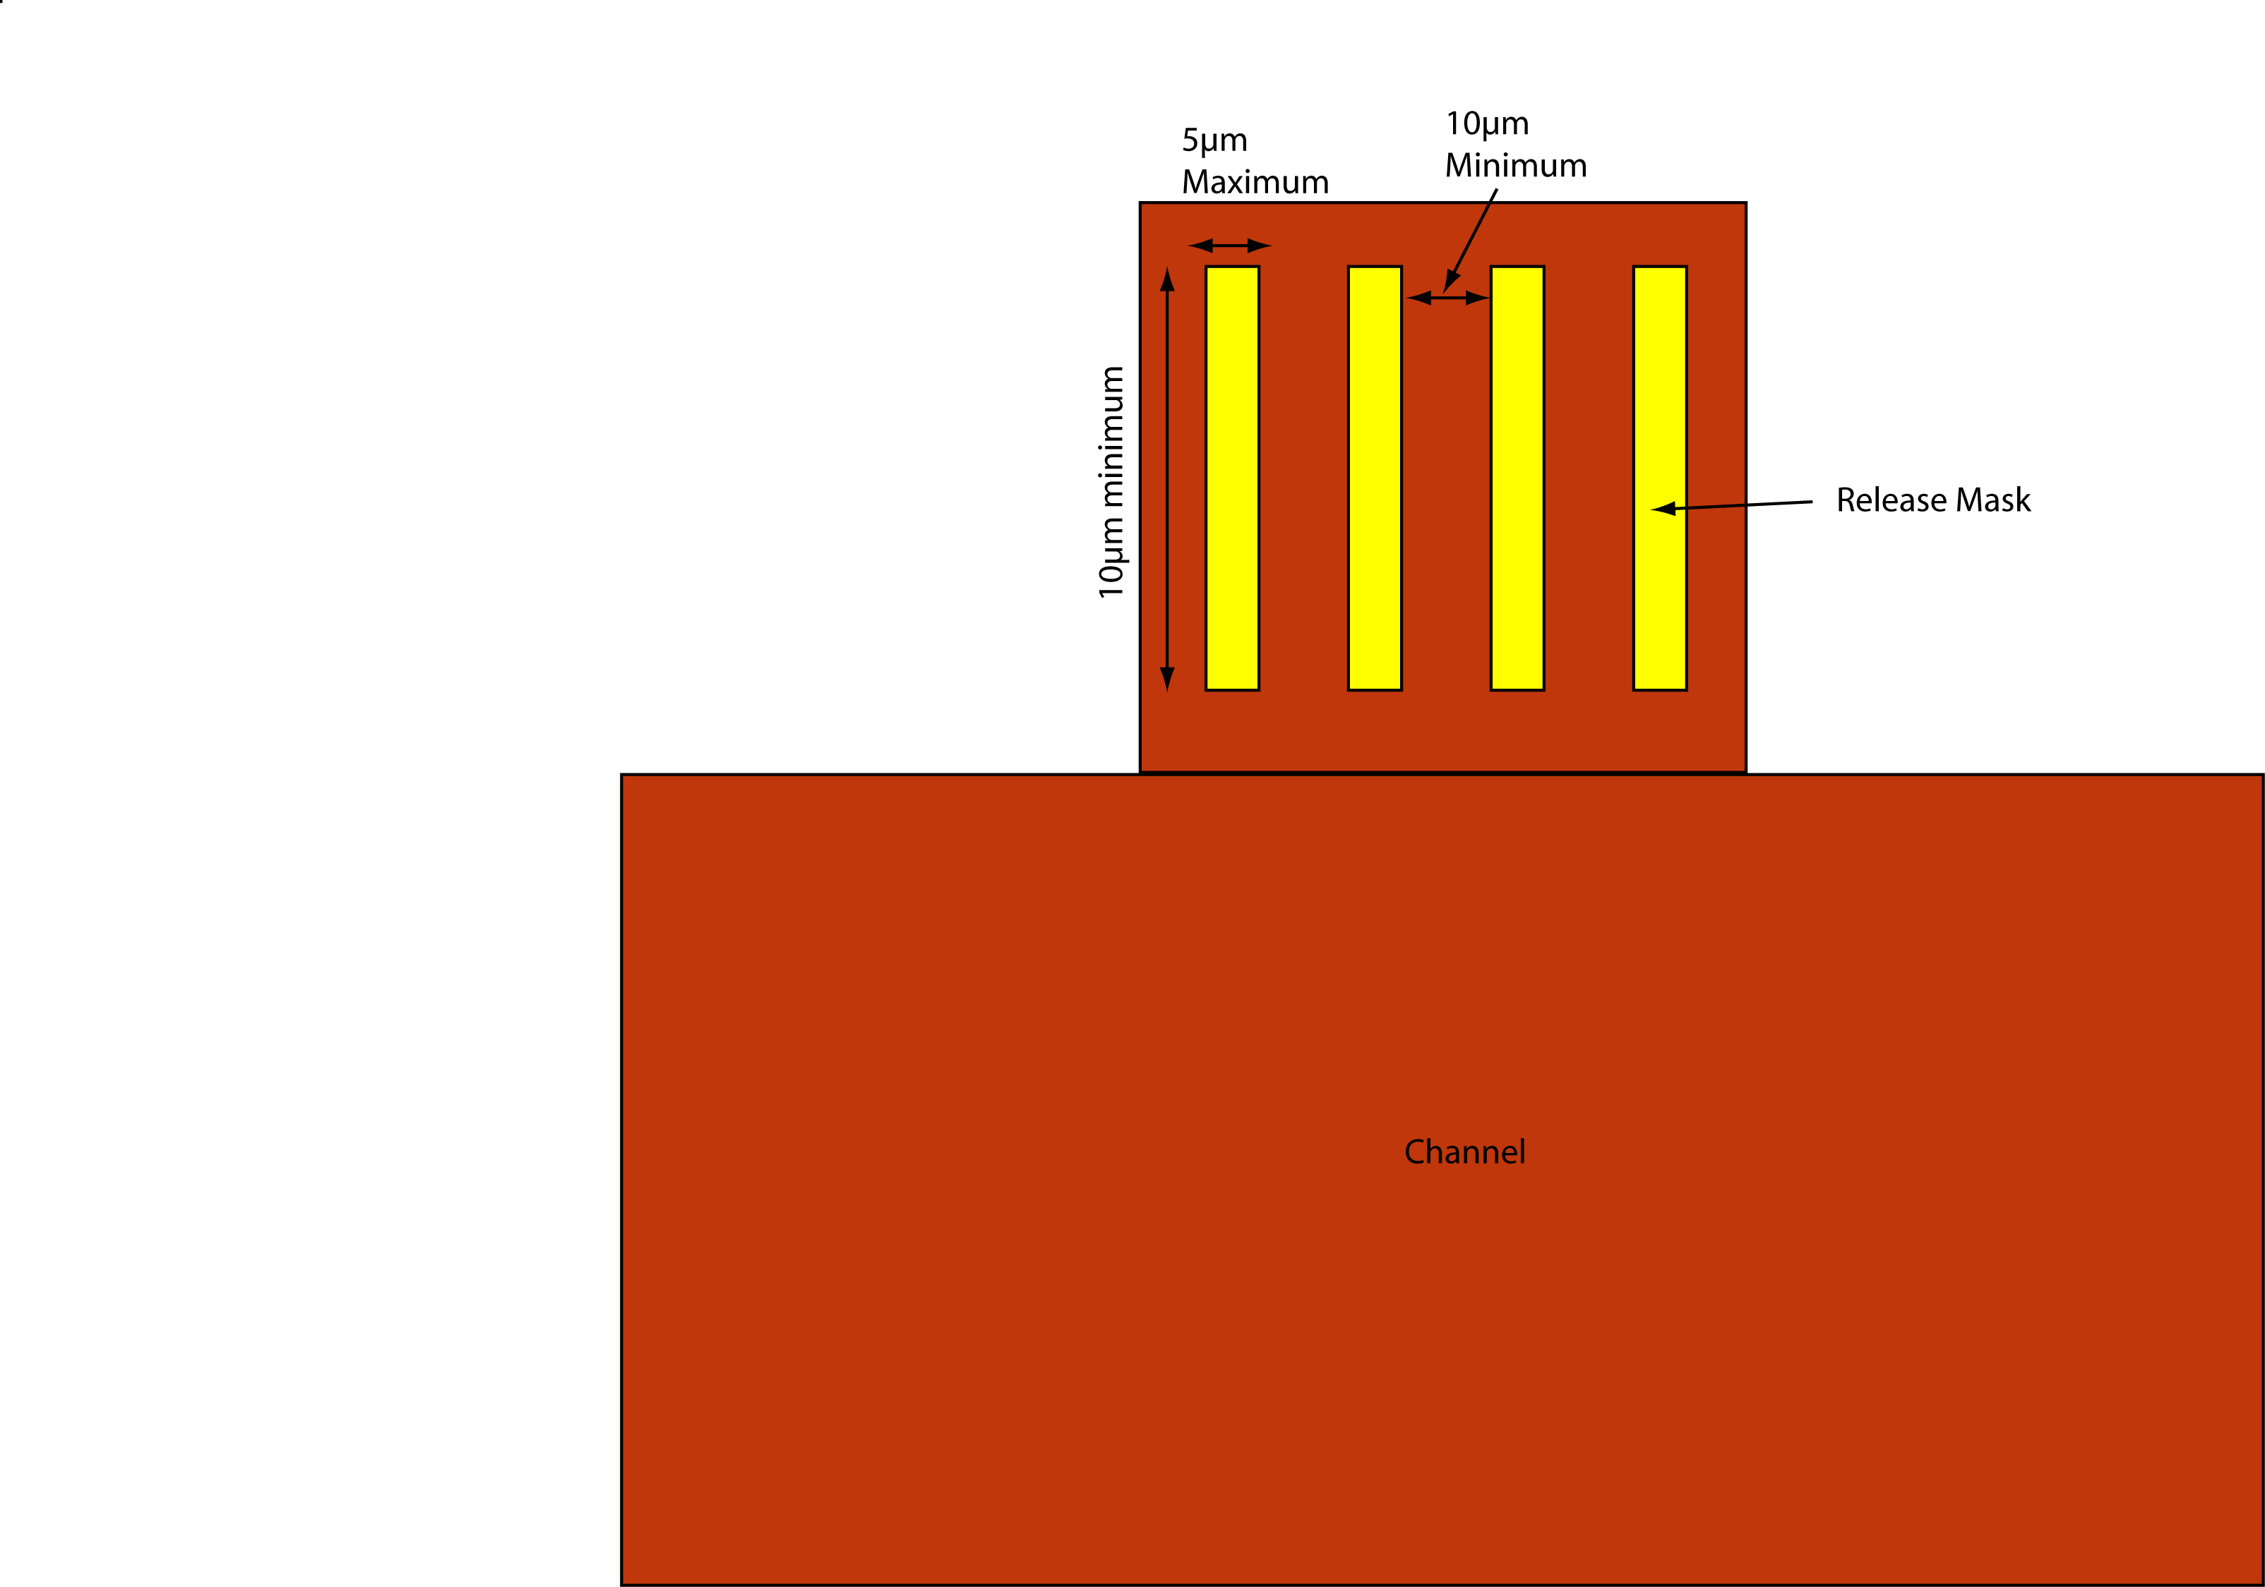

Fig. 2.2. Patterns on the RELEASE mask (yellow boxes) which will become openings on parylene. If these openings are placed over the sacrificial photoresist patterns as shown in Figs. 1.3 and 1.4, these patterns will serve as release holes to release sacrificial photoresist in parylene channels.

2.5 Access Mask
ACCESS mask is formed to open reservoir and electrode pad openings. The masking layer is a metal (0.5 μm thick titanium). Where the mask is drawn, the titanium will be etched away. According to conventions in table 2.1, if a box is drawn in the ACCESS layer and not in the SU-8 mask, it means titanium and eventually parylene will be etched. Because the titanium layer patterned by this mask will be on the wafer even after SU-8 patterns are formed, this layer should not be in the areas where there will be SU-8 patterns. As a result, boxes must be drawn in the ACCESS mask where reservoir and electrode pad openings are wanted and where there would be SU-8 patterns. Any box drawn on top of a channel means there would be a hole there. For the micro-fluidic connections, the SU-8 mask must overlap the ACCESS mask by 10 µm as shown in Fig. 2.4.
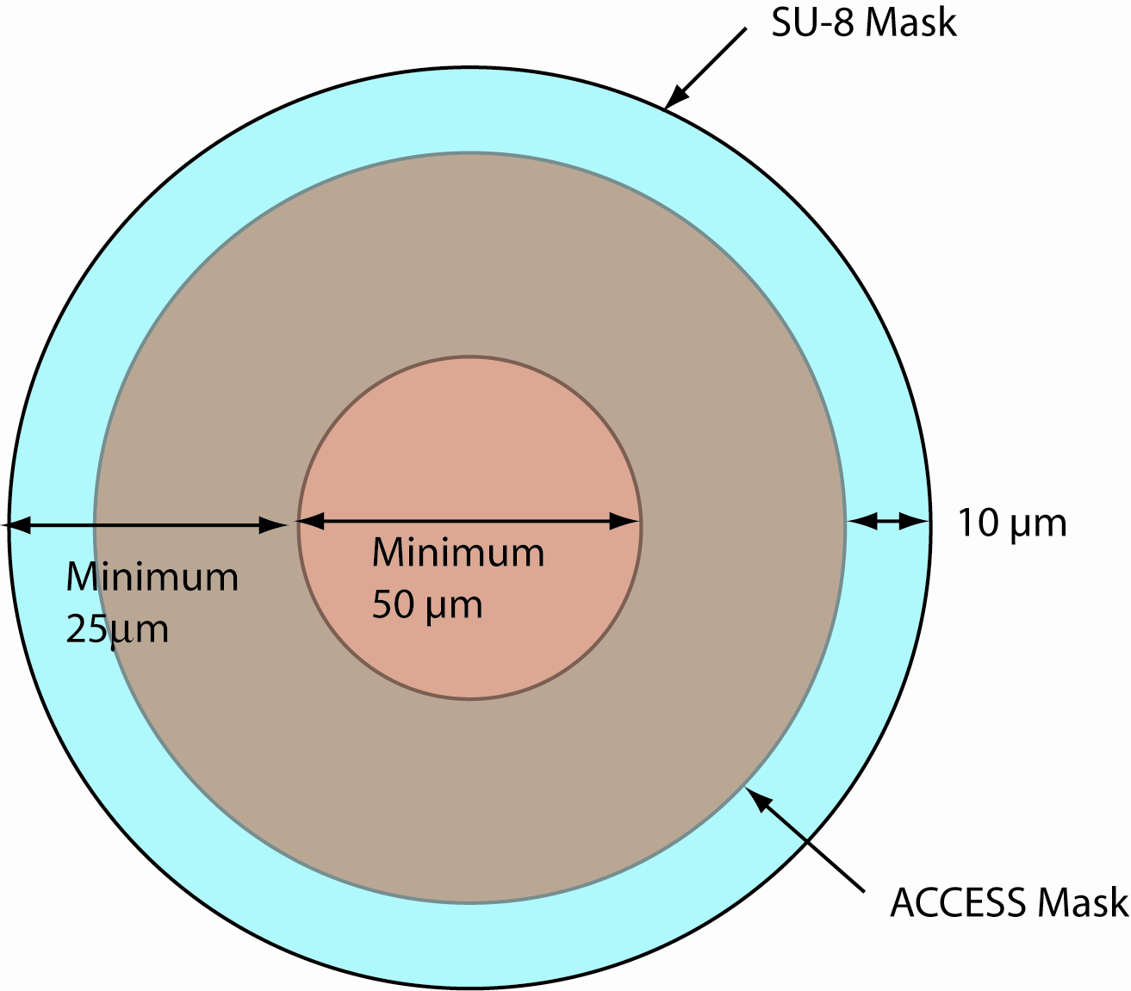
Fig. 2.4. Drawing of access port for connection to micro-fluidic conduit

2.6 SU-8 Mask
SU-8 mask is used to pattern 75 μm thick SU-8 layer. According to the convention in table 2.1, a box drawn in this layer will stay as an SU-8 pattern in the real wafer. There should not be any SU-8 pattern in the reservoir and electrode pad openings. Otherwise these openings can not be made. Furthermore, because after SU-8 is patterned there is a 1 hour oxygen plasma etch, SU-8 surface during this etch gets roughened. As a result, SU-8 patterns lose their optical clarity. If optical clarity is desired on microfluidic channels, then there should not be any patterns on these areas. If optical clarity is not necessary, SU-8 can be placed over the channels, adding strength to the layer. It is also recommended that the diameter of the SU-8 for the tub connections, be as large as the outside diameter of the tube that will be connected to the micro-fluidic port. This will allow easier mounting of the tubing to the system. The minimum drawn feature size for the SU-8 is 25 µm and spacing between drawn areas is 50 µm as shown in Fig. 2.4.

2.7 Die Size
Because there will be multiple projects on a single wafer, a die size of 2cm x 2cm has been set for the beta test run. In the future, any sized die will be possible.

2.8 Design Submission
PMEMS designs must be submitted through the MEMS Exchange (MX) system. Customers must sign up for the run, register with MX and submit their design through MX. For the Beta-test run, a free work order will be generated by MX for the processing of these chips.

2.9 Design recommendations
These micro-fluidic channels are sealed by 10 micron of Parylene and the adhesion of Parylene to Parylene will not withstand high pressures associated with many micro-fluidic applications. Therefore, to achieve optimal flow through the channels it is recommended that the solution be drawn through the channels (vacuum at the outlet) rather than pumped into the channels. The pressure to pass fluid is therefore limited to 15 PSI (1 atmosphere of pressure). It is necessary to consider this limitation when designing the micro-fluidic system.

As an additional design consideration, the uniformity of the channels must be determined. The thickness will be nominally 10 µm, but due to the surface of the Parylene and the thickness of the resist there will be an edge bead. I will do a mapping of the resist thickness to determine how much area this will effect. (Note: I am working on getting this data now. I will include a picture map of the thickness of the resist around the area of the wafer. Small changes in the thickness can significantly affect the channel pressure necessary for pumping solution through the conduits).

Chapter 3
Materials properties
Property | Parylene C
Melting Point (°C) | 290
Glass Transition (°C) | 13
Linear Coefficient of Expansion at 25°C | 3.5
Thermal Conductivity (x10-4cal/(cm • s • °C) | 2.0
Young’s Modulus (psi) | 400,000
Density (g/cm3) | 1.289
Index of Refraction | 1.639
Volume Resistivity (Ω • cm) | 3.1
Dielectric Constant (1KHz) | 3.1
Dielectric Strength (Volts/mil) | 5600
Wetting Angle | 75°

